Nepal College of Information Technology
Assessment
Spring 2012
Program : ELX Time : 3 hrs
Semester : (II) FM : 100
Subject : Engineering Math-II PM : 50

- Candidates are requested to give their answer as far as practicable in their own words.
- The figure in the margin indicates the full marks
- Attempt ALL question

1 a) Find the equation of the plane through the intersection of the plane 2x+3y+10z=8 and 2x-3y+7z=2 and normal to the plane 3x-2y+4z=5 8
b) \Show that the origin lies in the obtuse angle between the plane 2x−y+2z+3=0 and 3x−2y+6z+8=0. Find the bisector of the acute angle between the above two plane. 7
2. a) State and prove second shifting theorem of Laplace transform. 8
b) Find f(t) if
i) 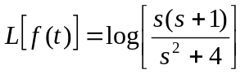
ii) 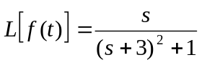 4+4

3. a) Solve 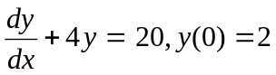 7
b) Solve 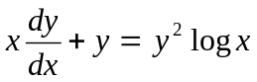 8
4. a) A rectangular box, open at the top, is to have a volume of 32 c.c. Find the dimension of the box requiring least material for its construction. 7

b) If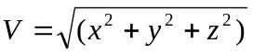 Show that Vxx+Vyy+Vzz = 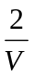 8

5. a) Solve: y" + 9y = 0 by power series method. 7

b) Verify Euler’s Theorem for u=x³+y³+z³−3xyz 7
6. a) Solve y" – 2y'+y=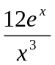 by using Variation of parameters. 7
b) Solve the initial value problem
y" +y'−2y=14+2x−2x² , y(0) = 0, y' (0) = 0 8
7. a) Find Laplace transform of t coswt 5*2
b) Find integrating of factor of 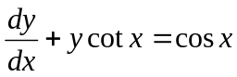
c) State Legendre’s Equation.
d) Solve 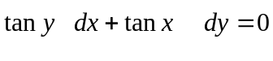
e) Find the equation of the plane through (4,5,1),(3,9,4)and (−4,4,4).

